AI TEXT SUMMARISER
A project report on Artificial Intelligence and Machine Learning.

Submitted by Team:
- Nrapendra Rao(L)
- Abhinav Katiyar
- Akshansh Kumar
- Tejas Gupta
- Anurag
Submitted to:
Mr. Aditya Bangia
Department of Computer Science & Engineering
IILM UNIVERSITY
GREATER NOIDA
Year--2025

CERTIFICATE

This is to certify that the project report titled “AI TEXT SUMMARISER” submitted by Nrapendra Rao(L) , Abhinav Katiyar , Akshansh Kumar , Tejas Gupta , Anurag in partial fulfillment of the requirements for the internship/project evaluation, is a bonafide work carried out under my supervision.

ACKNOWLEDGEMENT

I would like to express my sincere gratitude to my project guide “ MR ADITYA BANGIA ” for providing valuable guidance, support, and encouragement throughout the development of this project. I am also thankful to the faculty members of our department for offering the necessary resources and a productive learning environment.

I extend my appreciation to my teammates for their cooperation and contribution in completing this project successfully. Finally, I would like to thank all the online resources, documentation, and tools that helped us understand and implement the AI Text Summarization system effectively.

INDEX (TABLE OF CONTENTS)

1). INTRODUCTION

2). METHODOLOGY

3). ALGORITHM

4). RESULT

5). CONCLUSION

6). REFERENCES

INTRODUCTION

Artificial Intelligence (AI) has changed how we process, analyse, and use information. As digital content like articles, research papers, news, blogs, and social media posts grows rapidly, it's becoming harder for people to read and understand large amounts of text quickly. To help with this, AI-based text summarization tools have become a key solution.

An AI Text Summarizer takes long text and turns it into a shorter, meaningful version while keeping the main ideas and overall message.
It uses advanced Natural Language Processing (NLP) and deep learning to look at sentence structures, find important details, and create concise summaries. Modern models like BART, T5, and GPT make it possible to create highly accurate summaries, either by extracting key parts or by rephrasing the content in a new way.

This project is about creating an efficient AI-powered text summarization tool that helps students, professionals, researchers, and readers save time and work more productively.
The system can take any long paragraph, process it, and produce a clear summary, making information easier to understand and faster to read.
METHODOLOGY

The approach used in this AI Text Summarizer project follows a series of organized steps to handle an uploaded PDF, extract text, create summaries, assess their quality, and show the results to the user. Each part of the process is built using Python, natural language processing tools, and a Gradio-based interface.
1). PDF Upload and Input Handling
- The user sends a PDF file using the Gradio interface.
- The system checks the file and passes it to a processing function.
2). Text Extraction
- The uploaded PDF is opened with pdfplumber.
- Text from each page is taken and put together into one long string.
- Any pages that are blank or can't be read are skipped without issues.
3). Extractive Summarization
- The extracted text is broken into sentences.
- The top five sentences are picked to make a basic extractive summary.
- This method uses direct sentences from the original text without changing them.
4). Abstractive Summarization
- The text is cut down to 900 characters because of the model's limits.
- A transformer-based model called DistilBART CNN-12-6 is used.
- The model creates an abstractive summary by rephrasing and rewriting the content using deep learning.
- The length of the summary is controlled using max_length and min_length settings.
5). ROUGE Score Evaluation
- The original text is compared with the abstractive summary using ROUGE-1, ROUGE-2, and ROUGE-L.
- Precision, Recall, and F1 scores are calculated.
- These scores help show how accurate and relevant the summary is.
6). Generating Downloadable Files
- The extractive summary is saved as "extractive.txt".
- The abstractive summary is saved as "abstractive.txt".
- A single PDF file with both summaries is made using ReportLab.
7). Output Rendering
- All results, including the summaries, files, and scores, are shown on the Gradio interface.
- Users can download the results directly using the provided buttons.
8). Deployment
- The Gradio app is started with share=True, allowing access and sharing through the cloud.

ALGORITHM
Algorithm Name:
PDF_Processing_and_Summarization Algorithm

Step-by-Step Algorithm
Step 1: Start
- Start running the PDF_Summarizer_AI () algorithm.
Step 2: Input PDF File
- Take a PDF file that the user uploads through the Gradio interface.
Step 3: Extract Text from PDF
- Open the PDF using pdfplumber.
- For every page in the PDF:
- Take out the text from the page.
- Add that text to a main text variable.
- If there is no text found, show an error message.
Step 4: Generate Extractive Summary
- Break the extracted text into sentences using the dot symbol.
- Pick the first five sentences.
- Combine them into one summary that is extractive in nature.
Step 5: Generate Abstractive Summary
- Limit the input text to 900 characters because of the model's processing limit.
- Send the text to the transformer-based summarization tool.
- Create an abstractive summary by setting:
- Maximum length = 220 characters
- Minimum length = 80 characters
- Store the generated AI summary.
Step 6: Compute ROUGE Evaluation Scores
- Set up a Rouge Scorer with ROUGE-1, ROUGE-2, and ROUGE-L measures.
- Compare:
Reference Text = the original text pulled from the PDF
Generated Summary = the abstractive summary created earlier
- Calculate:
Precision
Recall
F1-Score
- Present these scores in a clear format.
Step 7: Save Output Files
- Save the extractive summary as extractive.txt
- Save the abstractive summary as abstractive.txt
- Make a new PDF using ReportLab with:
1). Extractive summary
2). Abstractive summary
- Save the final combined PDF as final_summary.pdf
Step 8: Display and Provide Downloads
- Go back to the user interface and show:
1). Extractive summary
2). Abstractive summary
- Download links for the two text files
- Download link for the combined PDF
- ROUGE evaluation scores\

SYSTEM ARCHITECTURE DESIGN
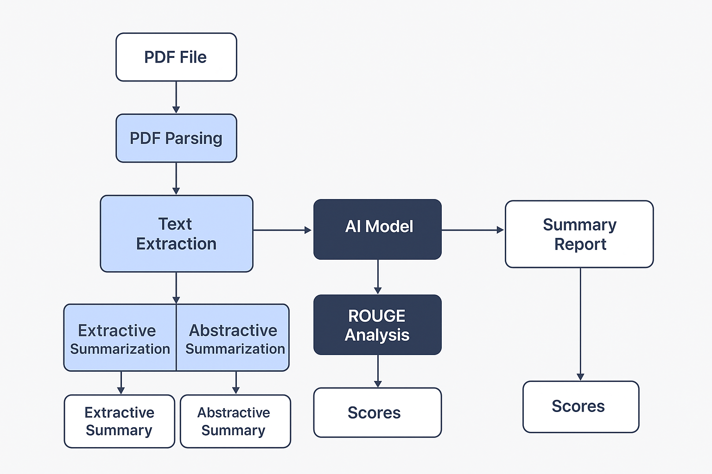

RESULT
The AI Text Summarizer effectively pulled text from the uploaded PDF and created both extractive and abstractive summaries. The system also measured ROUGE scores to check how good the summaries were. All the results were shown clearly on the Gradio interface, and the summaries could be downloaded as text files and as a single PDF. The model worked well and made useful summaries, showing that the system is effective.

1). PLATFORM WHERE OUR SUMMARIZATION WILL TAKE PLACE.
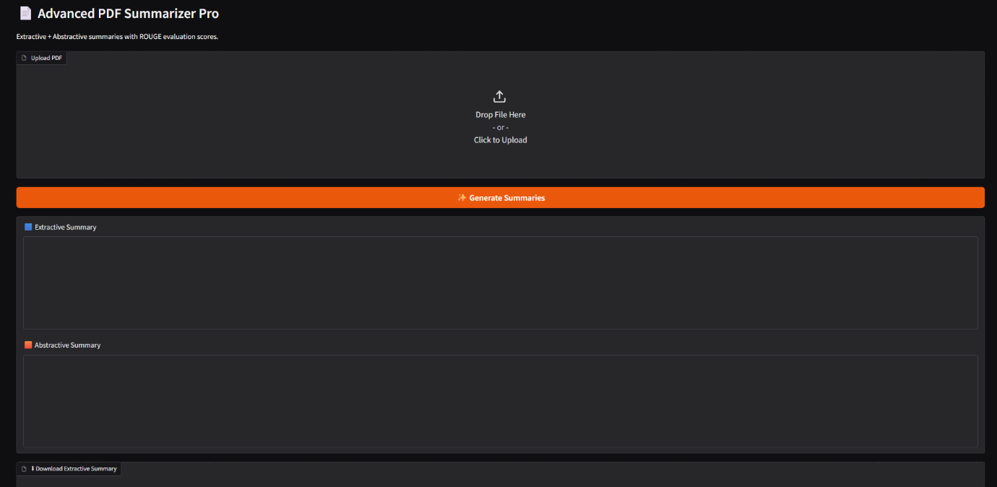
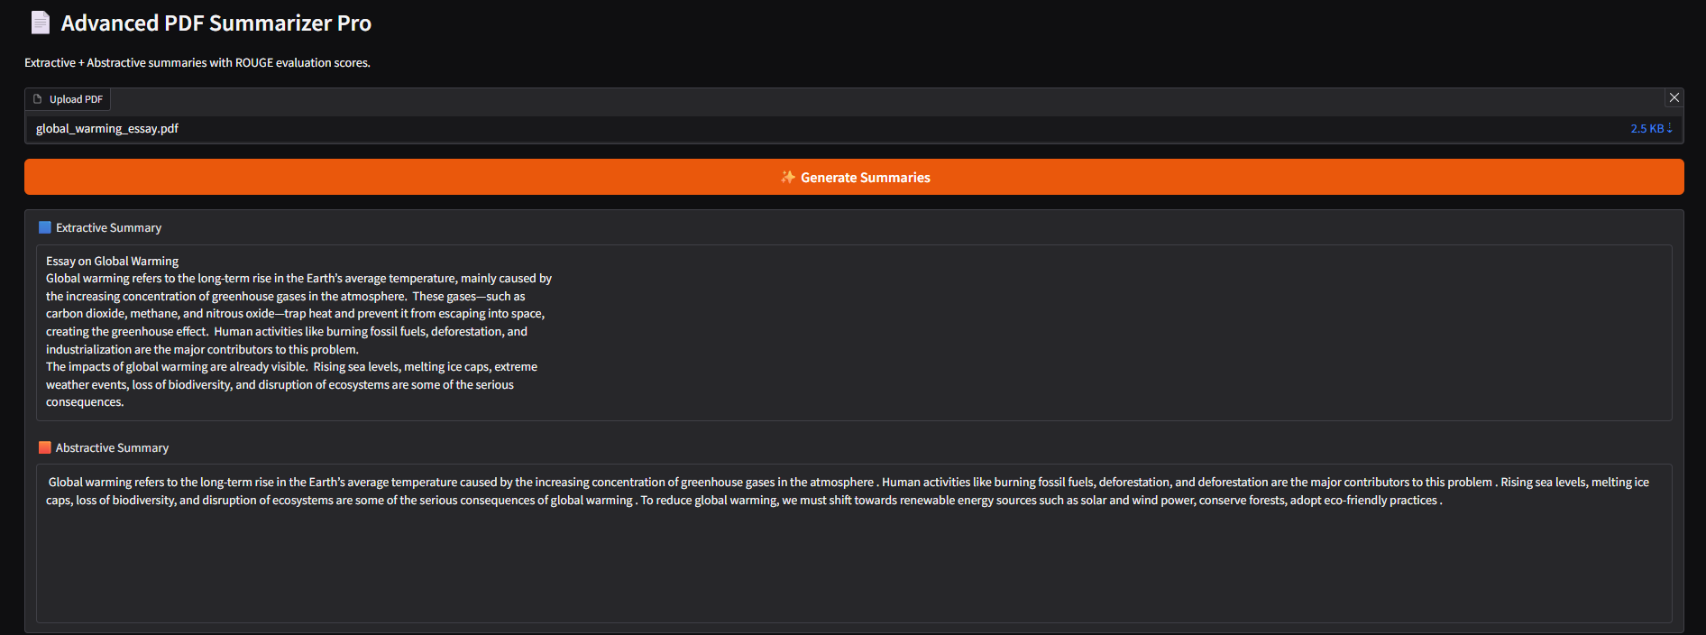
2). GENERATED SUMMARY OF THE ESSAY

3). ROUGE SCORES FOR PRECISION AND ACCURACY

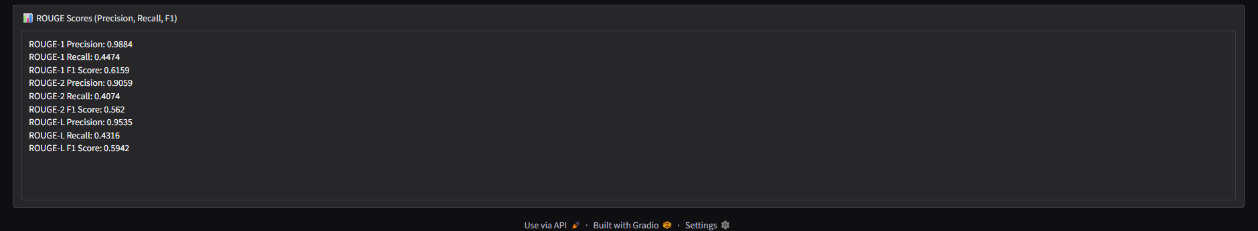

4). OPTION FOR DOWNLOADING FILES
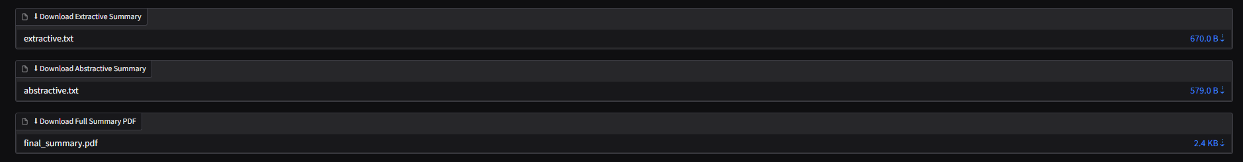

CONCLUSION

In this project, we successfully built an AI-powered PDF text summarizer that can create both extractive and abstractive summaries, along with ROUGE evaluation scores. The system works by extracting text from PDF files, using natural language processing and transformer models to process the content, and then showing the summaries through an interactive Gradio interface. The project shows how AI and NLP can be used in real-world situations to make handling large text files easier. Overall, the system works well, is easy to use, and achieves all the goals we set out to meet.

TEAM CONTRIBUTION
NRAPENDRA RAO
- PDF Handling & Text Extraction
- Implemented the ability to upload PDF files
- Wrote a module to extract text using pdfplumber
- Made sure the system works well with documents that have multiple pages

AKSHANSH
- Extractive Summarization
- Designed the logic for extractive summarization
- Created a system to extract sentences for summaries
- Checked the quality of summaries across different types of documents
ANURAG
- Abstractive Summarization (AI Model)
- Integrated a transformer model called DistilBART
- Adjusted settings like max_length and min_length
- Made sure the AI summaries were of high quality

TEJAS GUPTA
- ROUGE Score Evaluation & File Generation
- Set up ROUGE-1, ROUGE-2, and ROUGE-L evaluation methods
- Built downloadable files for the summaries
- Created a PDF report for the summaries using ReportLab

ABHINAV KATIYAR
- Gradio UI & Final Integration
- Developed the user interface with Gradio
- Linked the UI elements to the backend functions
- Did thorough testing and fixed any issues in the whole system

REFERENCES
- HuggingFace Transformers Documentation –
https://huggingface.co/docs/transformers
- DistilBART Model (sshleifer/distilbart-cnn-12-6) – https://huggingface.co/sshleifer/distilbart-cnn-12-6
- Gradio Documentation – https://gradio.app
- pdfplumber Library – https://github.com/jsvine/pdfplumber
- ReportLab PDF Toolkit – https://www.reportlab.com/docs/
- ROUGE Score Package – https://github.com/google-research/google-research
- Python Official Documentation – https://docs.python.org/
- CNN/DailyMail Dataset (Used for model training) – https://huggingface.co/datasets/cnn_dailymail
- Gigaword Dataset (Used for summarization research) – https://huggingface.co/datasets/gigaword
- Learning Resources & Code References: StackOverflow, Google AI Blog, Towards Data Science, YouTube Tutorials.

